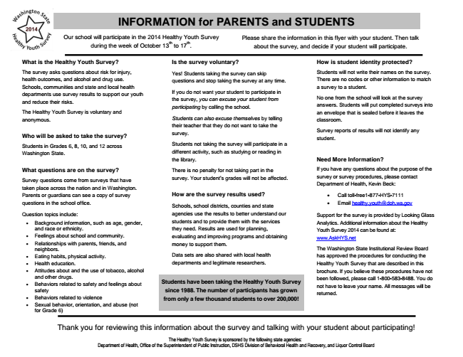

Our school will participate in the 2014 Healthy Youth Survey
during the week of October 13
th
to 17
th
.
What is the Healthy Youth Survey?
The survey asks questions about risk for injury, health outcomes, and alcohol and drug use. Schools, communities and state and local health departments use survey results to support our youth and reduce their risks.
The Healthy Youth Survey is voluntary and anonymous.
Who will be asked to take the survey?
Students in Grades 6, 8, 10, and 12 across Washington State.
What questions are on the survey?
Survey questions come from surveys that have taken place across the nation and in Washington. Parents or guardians can see a copy of survey questions in the school office.
Question topics include:
• Background information, such as age, gender, and race or ethnicity.
• Feelings about school and community.
• Relationships with parents, friends, and neighbors.
• Eating habits, physical activity.
• Health education.
• Attitudes about and the use of tobacco, alcohol and other drugs.
• Behaviors related to safety and feelings about
Students have been taking the Healthy Youth Survey safety
since 1988. The number of participants has grown
• Behaviors related to violence
from only a few thousand students to over 200,000!
• Sexual behavior, orientation, and abuse (not for Grade 6)
Thank you for reviewing this information about the survey and talking with your student about participating!
The Healthy Youth Survey is sponsored by the following state agencies: Department of Health, Office of the Superintendent of Public Instruction, DSHS Division of Behavioral Health and Recovery, and Liquor Control Board
INFORMATION for PARENTS and STUDENTS
Please share the information in this flyer with your student. Then talk about the survey, and decide if your student will participate.
Is the survey voluntary?
Yes! Students taking the survey can skip questions and stop taking the survey at any time.
If you do not want your student to participate in the survey, you can excuse your student from participating by calling the school.
Students can also excuse themselves by telling their teacher that they do not want to take the survey.
Students not taking the survey will participate in a different activity, such as studying or reading in the library.
There is no penalty for not taking part in the survey. Your student’s grades will not be affected.
How are the survey results used?
Schools, school districts, counties and state agencies use the results to better understand our students and to provide them with the services they need. Results are used for planning, evaluating and improving programs and obtaining money to support them.
Data sets are also shared with local health departments and legitimate researchers.
How is student identity protected?
Students will not write their names on the survey. There are no codes or other information to match a survey to a student.
No one from the school will look at the survey answers. Students will put completed surveys into an envelope that is sealed before it leaves the classroom.
Survey reports of results will not identify any student.
Need More Information?
If you have any questions about the purpose of the survey or survey procedures, please contact Department of Health, Kevin Beck:
• Call toll-free1-877-HYS-7111
• Email healthy.youth@doh.wa.gov
Support for the survey is provided by Looking Glass Analytics. Additional information about the Healthy Youth Survey 2014 can be found at: www.AskHYS.net
The Washington State Institutional Review Board has approved the procedures for conducting the Healthy Youth Survey that are described in this brochure. If you believe these procedures have not been followed, please call 1-800-583-8488. You do not have to leave your name. All messages will be returned.

